# Report No. 3 Software Requirement Specification

## User Requirement Specification

### Unauthorized User Requirement

Unauthorized Users are those do not login to this system. They only have one function.

* Login.

### Authorized User Requirement

Authorized Users are those have logged into this system. They have two functions.

* Edit profile.
* Logout.
* Search account.
* Search book.

### Borrower Requirement

Borrowers are those go to library with the purpose of searching books to read. In the case they want to read at home, they can borrow books. They can use some following functions:

* + Check in.
  + Check out.
* Add wish list book.
* View borrowed list.
* Extend borrowing books deadline.

### Librarian Requirement

Librarian is the user who interacts directly to borrower, they can use some following functions:

* Manage borrowers:
  + - * Add borrowers.
      * Update borrowers.
      * Activate borrowers.
      * Deactivate borrowers.
* Manage books:
  + - * Add new books.
      * Update books.
      * Delete books.
* Check out borrowers.
* View borrowing book list.

### Admin Requirement

Admin, who is responsible for managing accounts for the whole system, has the following function:

* Manage accounts:
  + - * Create account.
      * Update account.
      * Delete account.

### Emulator Requirement

Emulator is the devices which can interact with mobile phone for check in and check out. It can use some following functions:

* Read & write RFID tags
* Verify user by NFC/QR code

### Auto Handler Requirement

Auto Handler is an intermediate entity which facilitates the flow of the whole system by automating the following functions:

* + Check in, out borrower
  + Push notification to borrowers.

## System Requirement Specification



### External Interface Requirement

#### User Interface

* The user interface uses Vietnamese/English language for mobile application and English language mobile application.
* The user interface displays best on 1280x768 resolutions on desktop, and 1080x1920 on mobile.

#### Hardware Interface

* Smartphone with:
  + - * BLE support (Bluetooth 4.0)
      * NFC support
* RFID Reader and tags use 125 kHz.
* Estimate Beacon.

#### Software Interface

* Mobile application : Android OS version 4.4 (or 5.0).
* Estimate cloud for manage beacons
* Estimate SDK for connect between mobile application and beacons.

#### Communication Protocol

* Use HTTP 1.1 to communicate between the web browser and the web server.
* Use HTTP 1.1 to communicate between the mobile application and the web service.
* Use BLE protocol for communication between the mobile application and the Estimate beacons.
* Use NFC protocol for communication between the mobile application and the emulator for check in.
* Use RFID protocol for communication between tags and reader.

### System Overview Use Case

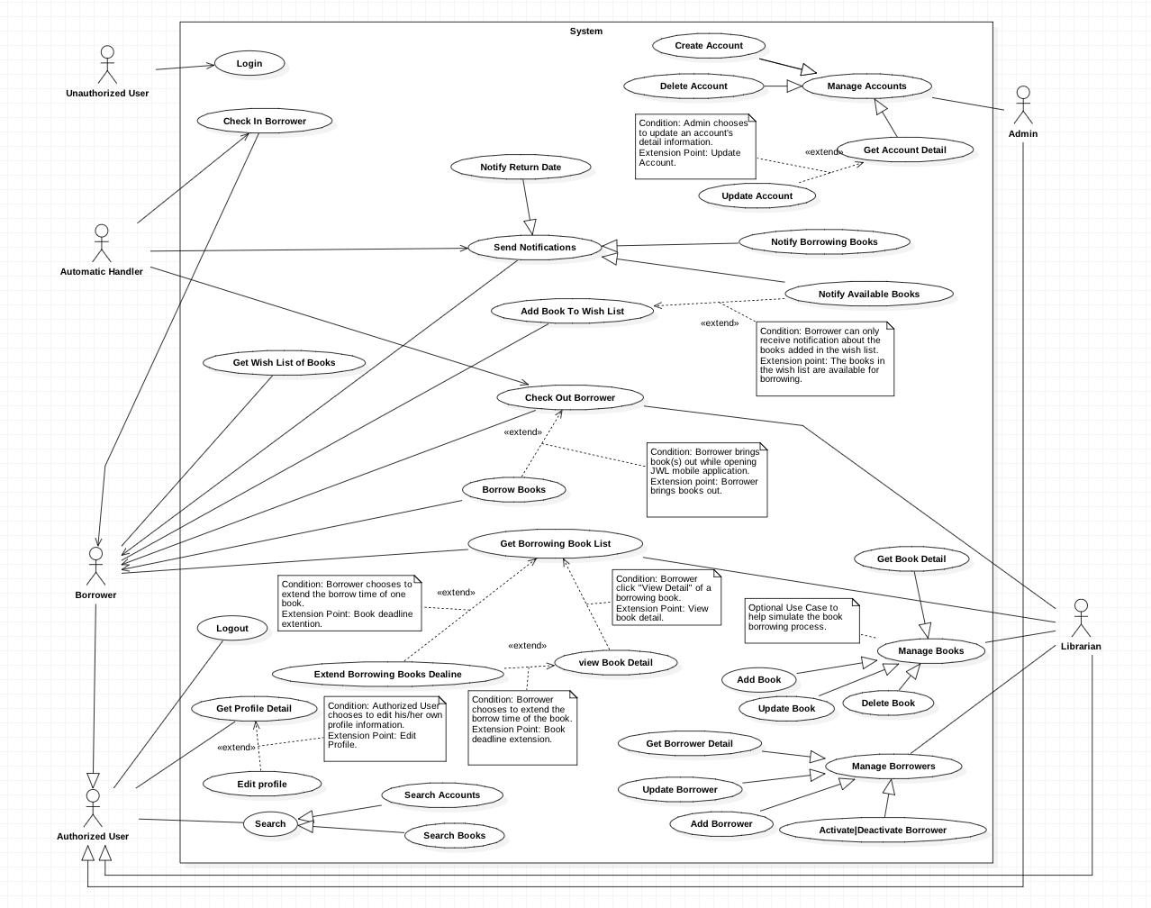

Figure 1 : <Use case> System overview



#### Web Application

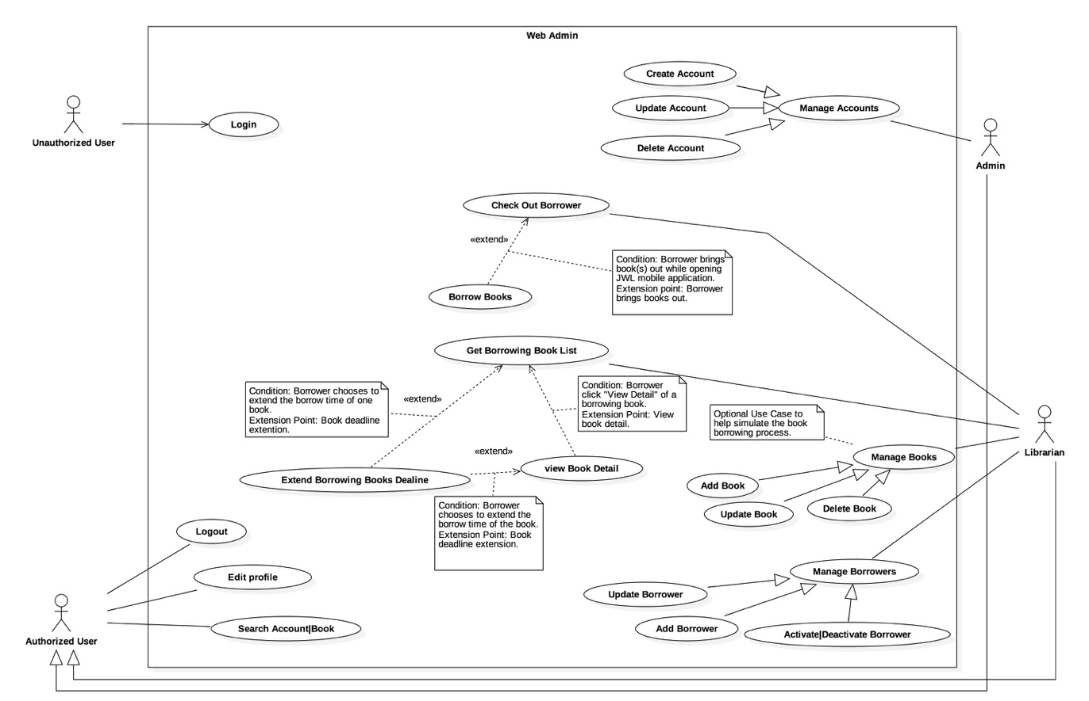

Figure 2: <Use case> Web application overview

#### Mobile Application

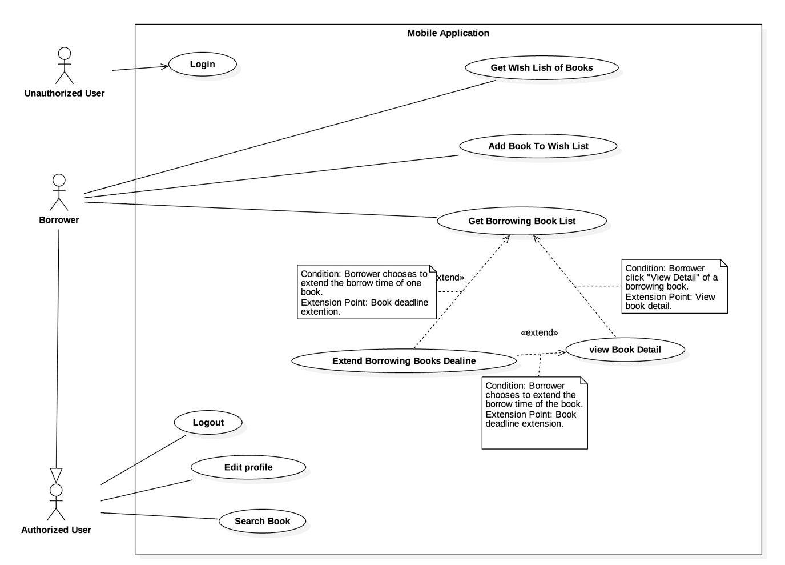

Figure 3: <Use case> Mobile application overview



### List of Use Case

#### Common Use Case

##### Unauthorized User

###### <Unauthorized User> Overview use case

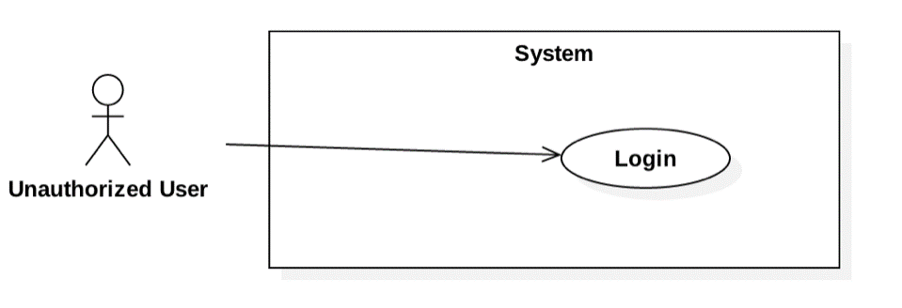

Figure 4: <Unauthorized User> Overview Use Case

###### <Unauthorized User> Login



Figure 5: <Unauthorized User> Login

|  |  |  |  |
| --- | --- | --- | --- |
| **USE CASE – JWL01** | | | |
| **Use Case No.** | JWL01 | **Use Case Version** | 1.0 |
| **Use Case Name** | Login | | |
| **Author** | Nguyen Tuan Anh | | |
| **Date** | February 15, 2017 | **Priority** | Normal |
| **Actor:**   * Unauthorized User.   **Summary:**   * This use case allows Unauthorized User to log into the system with a specific role.   **Goal:**   * Authenticate user, redirect user to a specific view based on the user’s role.   **Triggers:**   * Unauthorized User sends Login command.   **Preconditions:** N/A  **Post Conditions:**   * **Success:** Unauthorized User is logged into the system as Authorized User. * **Fail:** N/A   **Main Success Scenario:**   |  |  |  | | --- | --- | --- | | Step | Actor Action | System Response | | 1 | Unauthorized User inputs user ID and password.  [Alternative 1] |  | | 2 | Unauthorized User sends Login command. | Unauthorized User will be logged into System with their specific role.  The system redirects to the role’s view. |   **Alternative Scenario:**   |  |  |  | | --- | --- | --- | | No. | Actor Action | System Response | | 1 | | Unauthorized user   * Leaves the user ID and password field empty, or * Inputs wrong user ID or password | System displays the error message: “Your user ID or password is invalid.” |   **Exception:** N/A  **Relationships:** This use case will be extended by all other use cases, depending on the Actor’s role in the system.  **Business Rules:**   * System authenticates Actor by checking the user ID and password. * Actor enters password in a free text field which hides the password. * Actor’s password must be encrypted before sending to server. * After logged in to the system, the Actor will be redirected to a specific view:   For web view:   * If the role is “Admin”, the system will display Admin view. * If the role is “Librarian”, the system will display Librarian view.   For mobile application view:  + If the role is “Borrower”, the system will display the mobile application’s view. | | | |

##### Authorized User

###### <Authorized User> Overview Use Case

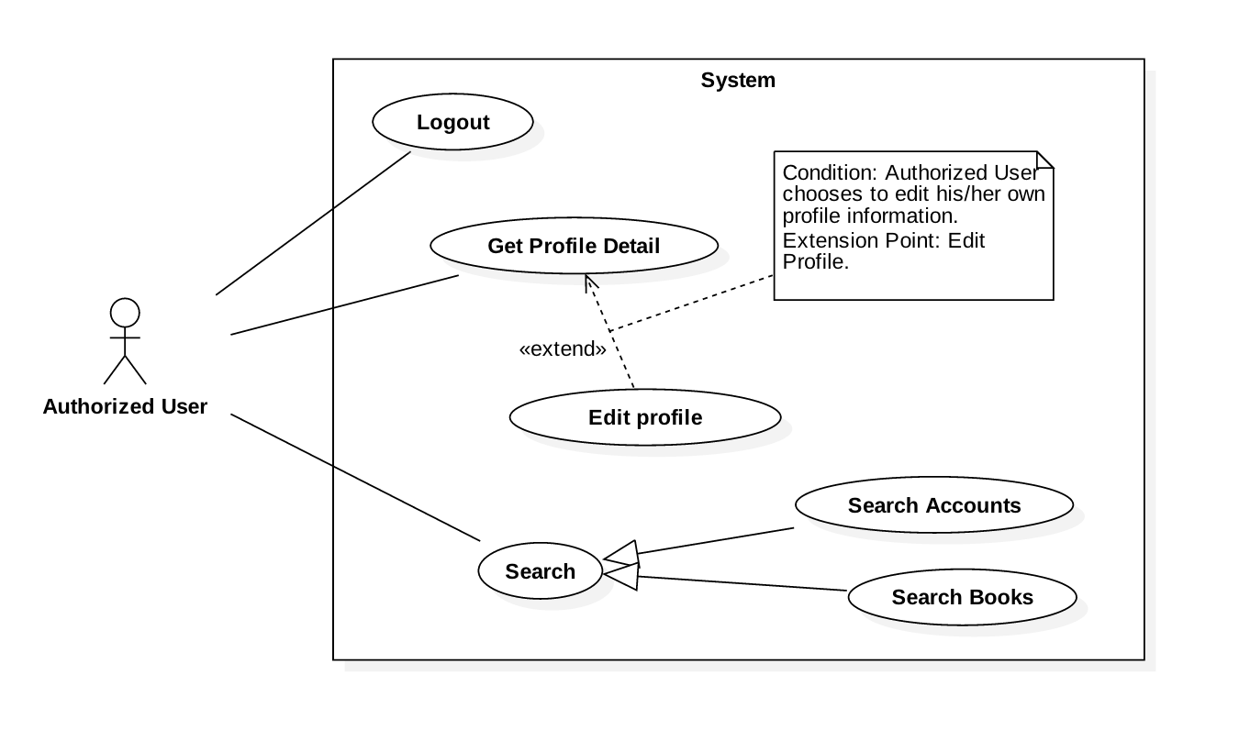

Figure 6: <Authorized User> Overview Use Case

###### <Authorized User> Get Profile Detail

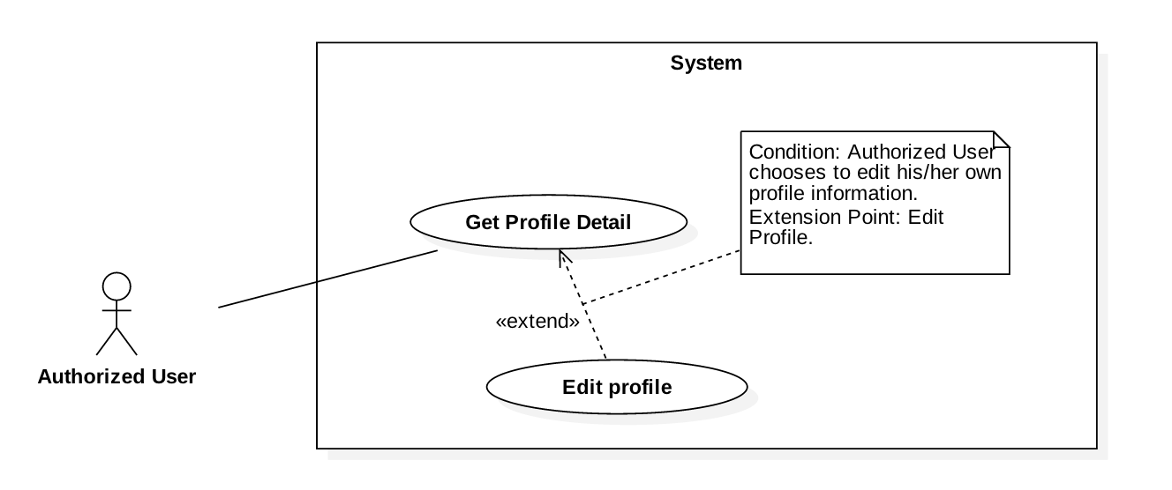

Figure 7: <Authorized User> Get Profile Detail

|  |  |  |  |
| --- | --- | --- | --- |
| **USE CASE – JWL02** | | | |
| **Use Case No.** | JWL02 | **Use Case Version** | 1.0 |
| **Use Case Name** | Get Profile Detail | | |
| **Author** | Nguyen Tuan Anh | | |
| **Date** | February 20, 2017 | **Priority** | Normal |
| **Actor:**   * Authorized User.   **Summary:**  This use case allows an Actor to view his/her profile detail information, including:   * + - * User image       * User ID       * Full name       * Date of Birth       * Email       * Address       * Phone number       * Place of Work       * User Role   **Goal:**   * The System shows the Actor his/her profile detail information.   **Triggers:**   * The Actor sends Get Profile Detail command.   **Preconditions:**   * The Actor logged into the system.   **Post Conditions:**   * **Success:** The System shows the Actor his/her profile detail information. * **Fail:** N/A.   **Main Success Scenario:**   |  |  |  | | --- | --- | --- | | Step | Actor Action | System Response | | 1 | Actor sends Get Profile Detail. | System shows the Actor his/her profile detail information:   * “User image”: image * “User ID”: label * “Full name”: label * “Date of Birth”: label * “Email”: label * “Address”: label * “Phone number”: label * “Place of Work”: label * “User Role”: label |   **Alternative Scenario:** N/A  **Exceptions:** N/A  **Relationships:** From this use case, an Actor can Edit Profile.  **Business Rules:**   * This use case only allows an Actor to get his/her own detail information. | | | |

###### <Authorized User> Logout

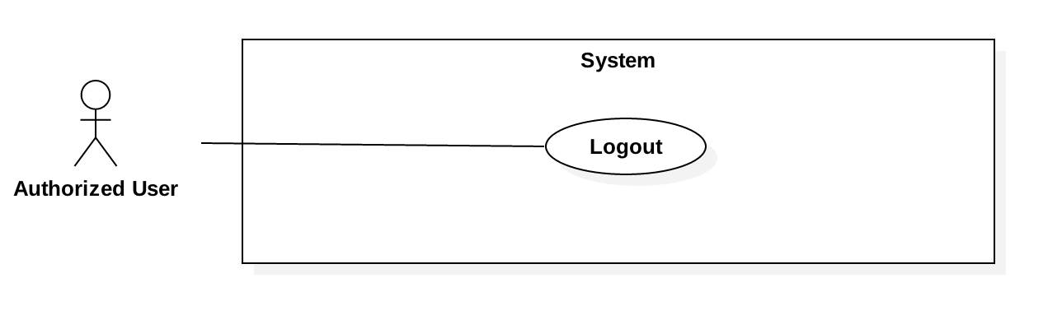

Figure 8: <Authorized User> Logout

|  |  |  |  |
| --- | --- | --- | --- |
| **USE CASE – JWL03** | | | |
| **Use Case No.** | JWL03 | **Use Case Version** | 1.0 |
| **Use Case Name** | Logout | | |
| **Author** | Nguyen Tuan Anh | | |
| **Date** | February 15, 2017 | **Priority** | Normal |
| **Actor:**   * Authorized User.   **Summary:**   * This use case allows Authorized User to log out off the system and become an Unauthorized User.   **Goal:**   * Invalidate the Authorized User, redirect the User to login view.   **Triggers:**   * Authorized User sends Logout command.   **Preconditions:**   * Actor logged in the system as an Authorized User.   **Post Conditions:**   * **Success:** Authorized User is logged out off the system and becomes Unauthorized User. * **Fail:** N/A   **Main Success Scenario:**   |  |  |  | | --- | --- | --- | | Step | Actor Action | System Response | | 1 | Authorized User sends Logout command.  [ Alternative 1] | System redirects the User to login view. |   **Alternative Scenario:**   |  |  |  | | --- | --- | --- | | No. | Cause | System Response | | 1 | | After at least one month not using the System, User sends any authorized commands. | System automatically redirects the User to login view. |   **Exceptions:** N/A  **Relationships:** N/A  **Business Rules:**   * Authorized User’s session ends after one month of inactivity. | | | |

###### <Authorized User> Edit Profile



Figure 8: <Authorized User> Edit Profile

|  |  |  |  |
| --- | --- | --- | --- |
| **USE CASE – JWL04** | | | |
| **Use Case No.** | JWL04 | **Use Case Version** | 1.0 |
| **Use Case Name** | Edit Profile | | |
| **Author** | Nguyen Tuan Anh | | |
| **Date** | February 16, 2017 | **Priority** | Normal |
| **Actor:**   * Authorized User.   **Summary:**  This use case allows an Actor to edit his/her personal information, including:   * + - * Full name       * Password       * Email       * Address       * Date of birth       * Phone number       * Place of work   **Goal:**   * Update the Actor’s personal information according to the Actor’s input.   **Triggers:**   * The Actor sends Edit Profile command.   **Preconditions:**   * The Actor must be logged into the System.   **Post Conditions:**   * **Success:** The Actor’s personal information is updated in the database. * **Fail:** System displays error messages according to fail reasons (see table **Exception**).   **Main Success Scenario:**   |  |  |  | | --- | --- | --- | | Step | Actor Action | System Response | | 1 | Actor sends Edit Profile command. | System lists out the information of the account:   * “Full name”: free text input * “Password”: free text input that hides user’s password * “Confirm Password”: free text input that hides users’ confirm password * “Date of Birth”: free text input that allows Actor to input day - month - year * “Email”: free text input * “Address”: free text input * “Phone number”: free text input * “Place of Work”: free text input | | 2 | Actor updates information. |  | | 3 | Actor sends Submit command. | * System validates the inputs then updates the account’s profile. * System redirect the Actor to the Get Profile Detail’s view. * System displays a successful message: “Update Successfully.”   [Exception 1, 2, 3, 4, 5, 6, 7] |   **Alternative Scenario:** N/A  **Exception:**   |  |  |  | | --- | --- | --- | | No | Cause | System Response | | 1 | Actor inputs Full Name field with the following wrong format:   * Blank, or all space characters * Longer than 100 characters. | System displays error messages:   * “Full name is required.” * “Full name must not be longer than 100 characters.” | | 2 | Actor inputs Password field with the following wrong format:   * Blank, or all space characters * Shorter than 6 characters * Longer than 50 characters | System displays error messages:   * “Password is required.” * “Password’s length is 6-50 characters.” | | 3 | Actor inputs Confirm Password field that does not match Password field. | System displays error message: “Confirm Password must match Password.” | | 4 | Actor inputs Email field with the following wrong format:   * Blank, or all space characters * Wrong email format (email format: [user.name]@[email.name]). | System displays error messages:   * “Email is required.” * “Wrong Email format. Please input something like your.name@mail.com” | | 5 | Actor inputs Address field with the following wrong format:   * Blank or all space characters * Longer than 250 characters | System displays error messages:   * “Address is required.” * “Address must not be longer than 250 characters.” | | 6 | Actor inputs Phone Number field with the following wrong format:   * Blank or all space characters * Wrong phone number format | System display error messages:   * “Phone Number is required.” * “Phone Number should be like +841692536224 or 01692536224.” | | 7 | Actor inputs Place of Work field with the following wrong format:   * Blank or all space characters * Longer than 100 characters | System displays error message:   * “Place of Work is required.” * “Place of Work must not be longer than 100 characters.” |   **Relationships:** Actor can only Edit Profile from Get Profile Detail.  **Business Rules:**   * Actor’s information must not be blank. * Full name’s and place of work’s length must not be longer than 100 characters. * Password’s length is 6-50 characters. * Confirm password must match input password. * Email must be in format: [user.name]@[email.name]. * Phone number must be in format: +[phone no.] or [phone no.] * Address’s length must not be longer than 250 characters. * Password and Confirm Password must be encrypted before saving to the system. * Actor cannot update username, or user role. * This use case only allows an Actor to update his/her own profile information. | | | |

###### <Authorized User> Search

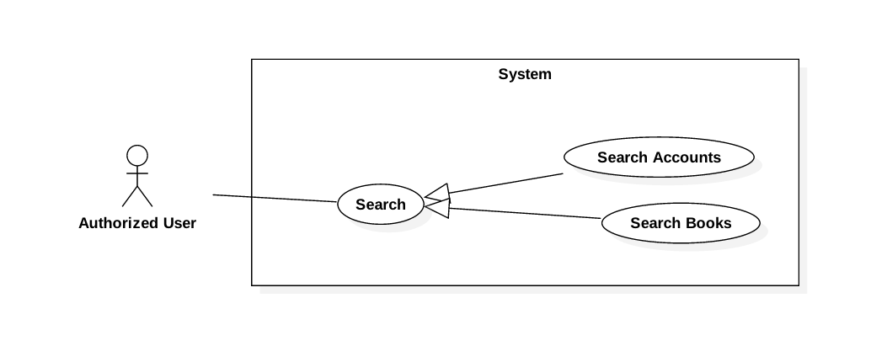

Figure 9: <Authorized User> Search

###### <Authorized User> Search Accounts

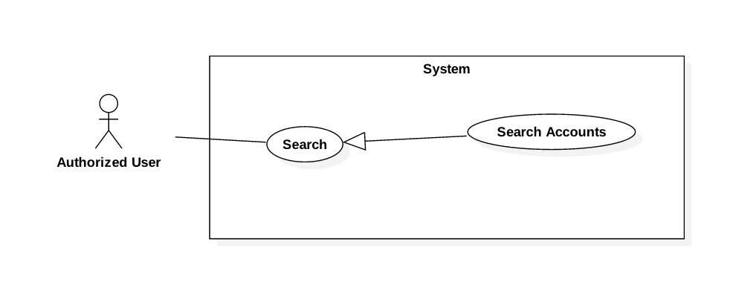

Figure 10: <Authorized User> Search Accounts

|  |  |  |  |
| --- | --- | --- | --- |
| **USE CASE – JWL05** | | | |
| **Use Case No.** | JWL05 | **Use Case Version** | 1.0 |
| **Use Case Name** | Search Accounts | | |
| **Author** | Nguyen Tuan Anh | | |
| **Date** | February 19, 2017 | **Priority** | Normal |
| **Actor:**   * Authorized User with role Admin or Librarian.   **Summary:**   * This use case allows an Actor to search Account by its user ID.   **Goal:**   * The Actor can get list of Accounts that best match his/her input user ID. The result list can vary based on the Actor’s role in the system:   + - * If the Actor’s role is Admin, the result list contains all kinds of Account (Admin, Librarian, Borrower).       * If the Actor’s role is Librarian, the result list contains only Borrowers.   **Triggers:**   * Authorized User sends Search Accounts command.   **Preconditions:**   * The Actor must be logged into the System. * The Actor must have role Admin or Librarian.   **Post Conditions:**   * **Success:**    + - * List of Accounts is showed based on the Actor’s search term.       * If there is no matched Account, the System shows message: “We couldn’t find any account with user ID like [user ID].” * **Fail:** N/A.   **Main Success Scenario:**   |  |  |  | | --- | --- | --- | | Step | Actor Action | System Response | | 1 | Actor inputs search term in the text input. |  | | 2 | Actor sends Search Accounts command. | System loads the search results with their information:  Account:   * “User ID”: label * “Full name”: label * “Phone Number”: label * “Role”: label, only visible if the Actor’s role is Admin * Is in library: label * Is activated: label   [Alternative 1] |   **Alternative Scenario:**  [Alternative 1]   |  |  |  | | --- | --- | --- | | No. | Cause | System Response | | 1 | There is no Account matches search term. | System shows message: “We couldn’t find any account with user ID like [user ID].” |   **Exception:** N/A  **Relationships:** From this Use Case, an Actor can:   * Get Account Detail if the Actor’s role is Admin. * Get Borrower Detail if the Actor’s role is Librarian.   (TODO: Update Links)  **Business Rules:**   * An Actor can only search Account by its user ID. * System lists all Accounts which user IDs contain the search term. * Only Admin and Librarian can search Accounts:   + - * Admin can search all Accounts: Admin, Librarian, and Borrower.       * Librarian can only search Borrower. | | | |

###### <Authorized User> Search Books

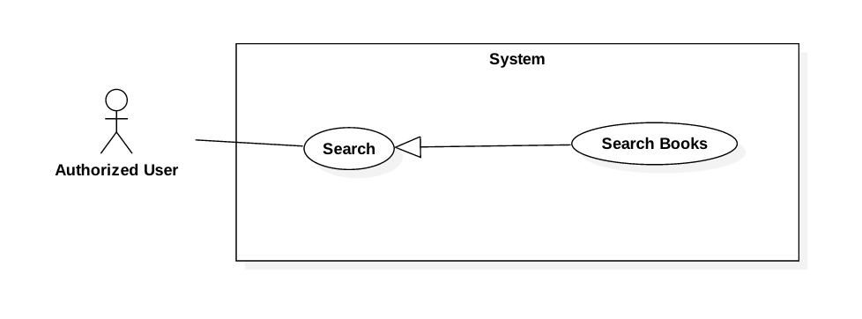

Figure 11: <Authorized User> Search Books

|  |  |  |  |
| --- | --- | --- | --- |
| **USE CASE – JWL06** | | | |
| **Use Case No.** | JWL06 | **Use Case Version** | 1.0 |
| **Use Case Name** | Search Books | | |
| **Author** | Nguyen Tuan Anh | | |
| **Date** | February 19, 2017 | **Priority** | Normal |
| **Actor:**   * Authorized User with role Librarian or Borrower.   **Summary:**   * This use case allows an Actor to search Books by:   + - * Title       * Author       * Type (textbooks, reference books, research papers, magazines, ...)       * Category (science, information technology, literature, physics, mathematics, …)       * Book copy’s ID (only available if the Actor’s role is Librarian)   **Goal:**   * The Actor can get list of Books that best match his/her input criteria.   **Triggers:**   * Authorized User sends Search Books command.   **Preconditions:**   * The Actor must be logged in the System. * The Actor must have role Librarian or Borrower.   **Post Conditions:**   * **Success:**    + - * List of Books is showed based on the Actor’s search criteria.       * If there is no matched Books, the System shows message: “We couldn’t find any book that match your description.” * **Fail:** N/A.   **Main Success Scenario:**   |  |  |  | | --- | --- | --- | | Step | Actor Action | System Response | | 1 | Actor inputs search term in the text input.  [Alternative 1] |  | | 2 | Actor sends Search Books command. | System loads the search results with their information:  Account:   * “Title”: label * “Author”: label * “Available Copies”: label   [Alternative 2] |   **Alternative Scenario:**  [Alternative 1]   |  |  |  | | --- | --- | --- | | No. | Actor Action | System Response | | 1 | Actor sends Advance Search commands.  Actor inputs wanted search criteria.  Actor send Search Books command. | System shows more search criteria:   * Title: free text input * Author: free text input * Type: list of available book types that allows the Actor to choose from * Category: list of available book categories that allows the Actor to choose from * Book copy ID: free text input, only visible if the Actor’s role is Librarian.   System loads the search results with their information:  Account:   * “Title”: label * “Author”: label * “Available Copies”: label | | 2 | There is no Book matches search term. | System shows message: “We couldn’t find any book that matches your description.” |   **Exception:** N/A  **Relationships:** From this Use Case, an Actor can   * Get Book Detail * Add Book To Wish List if the Actor’s role is Borrower, and the Book is not currently available   (TODO: Update links)  **Business Rules:**   * Only Librarian and Borrower can search Books:   + - * Both Librarian and Borrower can search Book by its title, author, type, category.       * Only Librarian can search Book by book copy ID. * System lists all Books that match all search criteria of the Actor. | | | |

#### Web Application

##### Admin

###### <Librarian> Overview Use Case

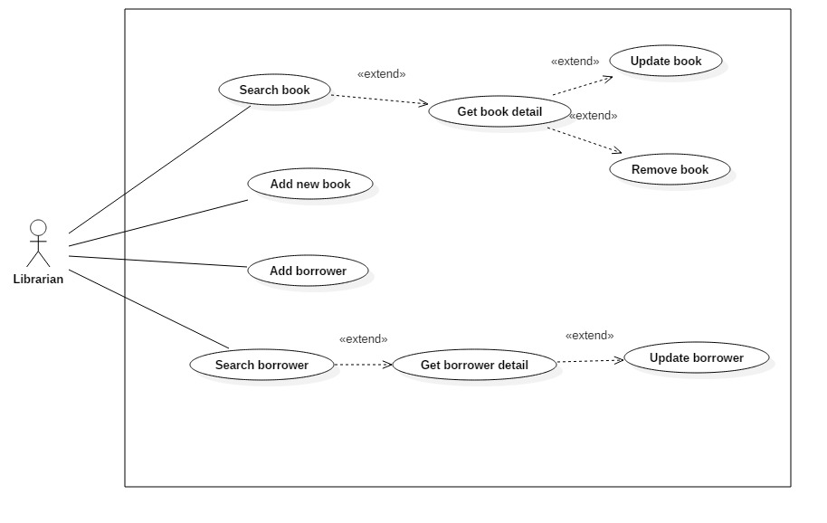

Figure 14: <Librarian> Overview Use Case

###### <Librarian> Search Book

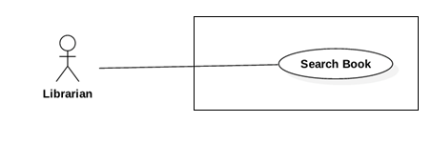

Figure 15: <Librarian> Search Book

|  |  |  |  |
| --- | --- | --- | --- |
| **USE CASE – JWL09** | | | |
| **Use Case No.** | JWL09 | **Use Case Version** | 1.0 |
| **Use Case Name** | Search Book | | |
| **Author** | Dang Nhat Thien | | |
| **Date** | February 12, 2017 | **Priority** | Normal |
| **Actor:**   * Librarian   **Summary:**   * This use case allows Librarian to search book in library to view book detail.   **Goal:**   * Librarian can get a list book that match input book’s id, book’s name. or book’s author.   **Triggers:**   * Librarian send Search command.   **Preconditions:**   * Actor logged in system with role Librarian.   **Post Conditions:**   * **Success:** List of matching books based on search term is showed. * **Fail:** N/A   **Main Success Scenario:**   |  |  |  | | --- | --- | --- | | Step | Actor Action | System Response | | 1.  2. | Librarian inputs wanted book’s id,  book’s name or book’s author.  Then send Search command. | System loads the result. Information for each book:   * No. * Book Title * Publisher * Description * Publish year * Number of pages * Number of copies (remain/total) * Book type * Position * ISBN * Category * Author   [Alternative 1] |   **Alternative Scenario:**   |  |  |  | | --- | --- | --- | | Step | Cause | System Response | | 1 | There is no book that matches the search term. | System shows message: “No book found.” |   **Exceptions:** N/A  **Relationships:** Search book successfully, so librarian can Update Book, Remove Book.(cu the quan he: ex: extends) (should)  **Business Rules:**   * Number of copies will show with format: [Remain] copies / [Total] copies. * Add action button to the last columns, so Librarian can Update, Remove Book. * Mo ta them ve giao dien * Du lieu (nen to chuc moi trang) * Author lay name tu bang author. | | | |

###### <Librarian> Add Book

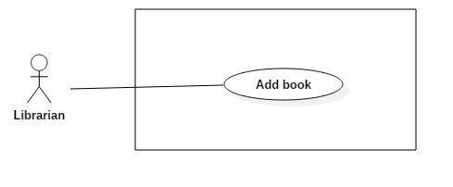

Figure 16: <Librarian> Add Book

|  |  |  |  |
| --- | --- | --- | --- |
| **USE CASE – JWL10** | | | |
| **Use Case No.** | JWL10 | **Use Case Version** | 1.1 |
| **Use Case Name** | Add Book | | |
| **Author** | Dang Nhat Thien | | |
| **Date** | March 15, 2017 | **Priority** | Normal |
| **Actor:**   * Librarian   **Summary:**   * Librarian adds new books with information Librarian input when library have new books.   **Goal:**   * New books are available in the library system.   **Triggers:**   * Actor sends “Add New Book” command.   **Preconditions:**   * Actor logged in system with role Librarian.   **Post Conditions:**   * **Success:** System show message: “Add successfully!” * **Fail:** N/A   **Main Success Scenario:**   |  |  |  | | --- | --- | --- | | Step | Actor Action | System Response | | 1  2  3 | Librarian send Add New Book  command.  Librarian input information.  [Alternative 1,2]  Librarian send “Save” command.  [Alternative 3] | System lists out the information of new Book:   * “Thumbnail”: default system image Upload image here, only JPG, PNG, JPEG format are accepted. Maximum file size is 3 MB, required. * “Book title”: free text input, required, length 1-50 * “Publisher”: free text input, required, length 1-100 * “Publish year”: free number input, required, max length 4 * “Page number”: free number input, required, length 1-4 * “Description”: free number input, required, length 1-500 * “Floor”: free number input, required, length 2 * “Shelf”: free text input, required, length 2. * “Author: free text input, required, length 1 – 50 * “Book type”: list of book type, required. * “Book category”: list of checkbox, required. * “RFID”: free text input, max length 10, required. * “Add new copy” command. * “Delete copy” command. * “Save” command. * “Cancel” command.   When text change, system verifies input information.  [Exception 1,2,3,4,5,6,7,8,9,10,11,12]  System verifies input information. New Book with all copies of it are saved to database. The system show message “Book [title] has been added!”  [Exception 1,2,3,4,5,6,7, 8, 9, 10, 11,12] |   **Alternative Scenario:**   |  |  |  | | --- | --- | --- | | No | Cause | System Response | | 1 | Librarian send “Add New Copy” command. | This corresponding RFID is display in a list below Book information. [Exception 6]  “RFID” will be clear. | | 2 | Librarian send “Delete Copy” command. | This corresponding RFID is deleted from list. | | 3 | Librarian send “Cancel” command. | System return to main view. |   **Exceptions:**   |  |  |  | | --- | --- | --- | | No | Cause | System Response | | 1 | Librarian inputs Book title field with wrong format. | System displays error message: “Book title’s length must be 1 - 50 characters.” | | 2 | Librarian inputs Publisher field with wrong format. | System displays error message: “Publisher’s length must be 1-100 characters.” | | 3 | Librarian inputs Publish year field with wrong format. | System displays error message: “Publish year must be a positive integer number and max length is 4” | | 4 | Librarian inputs Page number field with wrong format. | System displays error message: “Page must be a positive integer number and max length is 4” | | 5 | Librarian inputs Description field with wrong format. | System displays error message: “Description’s length is 1 - 500 characters” | | 6 | Librarian inputs RFID field with wrong format. | System displays error message: “RFID’s length is 10 characters.” | | 7 | Librarian send Save command with no RFID is added. | System display error message: “Please input at least one RFID.” | | 8 | Librarian inputs Floor field with wrong format. | System displays error message: “Floor must be a positive integer number and max length is 2” | | 9 | Librarian inputs Shelf field with wrong format. | System display error message: “Shelf length is 2 characters” | | 10 | Librarian inputs Author field with wrong format. | System display error message: “Author length is 1 – 50 characters”. | | 11 | Librarian pick up wrong format file. | System display error message: “Image extension are JPG, JPEG, PNG only and maximum size 3MB” | | 12 | Librarian does not pick up an image. | System display error message: “Please choose a thumbnail for book.” |   **Relationships:** Add successfully a new book so librarian can search, update, remove this.  **Business Rules:**   * “Book title”: free text input, length 1-50. * “Publisher”: free text input, length 1-100. * “Publish year”: free text input, length 4. * “Page Number”: free text input, length 1-4. * “Description”: free text input, length 1-500. * “RFID”: free text input, length 10. * “Floor”: free text input, length 2. * “Shelf”: free text input, length 2. * “Author”: free text input, length 1-50. * RFID must be added whenever Add New Book. * Floor and Shelf are two attributes of Position. | | | |

###### <Librarian> Get Book Detail

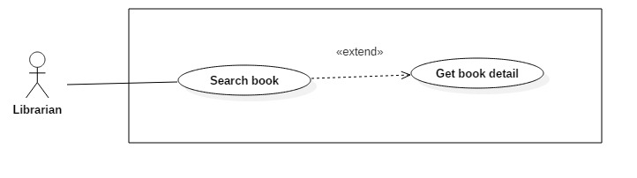

Figure 17: <Librarian> Get Book Detail

|  |  |  |  |
| --- | --- | --- | --- |
| **USE CASE – JWL11** | | | |
| **Use Case No.** | JWL15 | **Use Case Version** | 1.0 |
| **Use Case Name** | Get Book Detail | | |
| **Author** | Dang Nhat Thien | | |
| **Date** | March 16, 2017 | **Priority** | Low |
| **Actor:**   * Librarian   **Summary:**   * This use case allows Librarian to view book detail. So Librarian can Update/Delete book.   **Goal:**   * Full information of book is displayed.   **Triggers:**   * Librarian sends View Book Detail command.   **Preconditions:**   * Actor logged in system with role Librarian. * Librarian find out the Book want to view detail via Search Book.   **Post Conditions:**   * **Success:** System show all information of a specific Borrower. * **Fail:** N/A.   **Main Success Scenario:**   |  |  |  | | --- | --- | --- | | Step | Actor Action | System Response | | 1 | Librarian sends View Book Detail. | System lists out the information of the book:   * Thumbnail * Book title * Publisher * Publish year * Page number * Description * Floor * Shelf * Author * Book type * Book category * List of RFID |   **Alternative Scenario:** N/A  **Exception:** N/A  **Relationships:** Librarian must find out the Book want to view detail via Search Book  **Business Rules:** N/A | | | |

###### <Librarian> Update Book

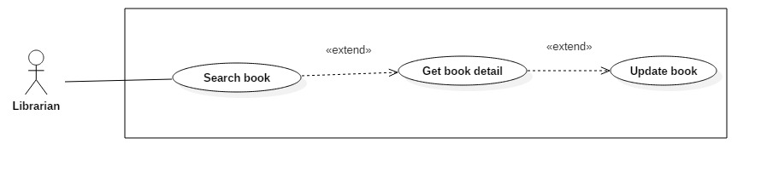

Figure 18: <Librarian> Update Book

|  |  |  |  |
| --- | --- | --- | --- |
| **USE CASE – JWL12** | | | |
| **Use Case No.** | JWL11 | **Use Case Version** | 1.1 |
| **Use Case Name** | Update Book | | |
| **Author** | Dang Nhat Thien | | |
| **Date** | March 15, 2017 | **Priority** | Normal |
| **Actor:**   * Librarian   **Summary:**   * This use case allows Librarian to update information of books.   **Goal:**   * Book’s information will be updated.   **Triggers:**   * Librarian send Update Book command.   **Preconditions:**   * Actor logged in system with role Librarian. * Librarian find out the Book want to update.   **Post Conditions:**   * **Success: S**ystem show message: “Update successfully!” * **Fail:** N/A   **Main Success Scenario:**   |  |  |  | | --- | --- | --- | | Step | Actor Action | System Response | | 1  2  3 | Librarian sends Update Book  command from a Book Detail.  Librarian input information.  [Alternative 1,2]  Librarian send “Save” command.  [Alternative 3] | System lists out the information of new Book:   * “Thumbnail”: default system image, only JPG, PNG, JPEG format are accepted. Maximum file size is 3 MB, required. * “Book title”: free text input, required, length 1-50 * “Publisher”: free text input, required, length 1-100 * “Publish year”: free number input, required, max length 4 * “Page number”: free number input, required, length 1-4 * “Description”: free number input, required, length 1-500 * “Floor”: free number input, required, length 2 * “Shelf”: free text input, required, length 2. * “Author: free text input, required, length 1 – 50 * “Book type”: list of book type, required. * “Book category”: list of checkbox, required. * “RFID”: free text input, max length 10, required. * “Add new copy” command. * “Delete copy” command. * “Save” command. * “Cancel” command.   When text change, system verifies input information.  [Exception 1,2,3,4,5,6,7,8,9,10,11,12]  System verifies input information. New Book with all copies of it are saved to database. The system show message “Book [title] has been added!”  [Exception 1,2,3,4,5,6,7, 8, 9, 10, 11,12] |   **Alternative Scenario:**   |  |  |  | | --- | --- | --- | | No | Cause | System Response | | 1 | Librarian send “Add New Copy” command. | This corresponding RFID is display in a list below Book information. [Exception 6]  “RFID” will be clear. | | 2 | Librarian send “Delete Copy” command. | This corresponding RFID is deleted from list. | | 3 | Librarian send “Cancel” command. | System return to main view. |   **Exceptions:**   |  |  |  | | --- | --- | --- | | No | Cause | System Response | | 1 | Librarian inputs Book title field with wrong format. | System displays error message: “Book title’s length must be 1 - 50 characters.” | | 2 | Librarian inputs Publisher field with wrong format. | System displays error message: “Publisher’s length must be 1-100 characters.” | | 3 | Librarian inputs Publish year field with wrong format. | System displays error message: “Publish year must be a positive integer number and max length is 4” | | 4 | Librarian inputs Page number field with wrong format. | System displays error message: “Page must be a positive integer number and max length is 4” | | 5 | Librarian inputs Description field with wrong format. | System displays error message: “Description’s length is 1 - 500 characters” | | 6 | Librarian inputs RFID field with wrong format. | System displays error message: “RFID’s length is 10 characters.” | | 7 | Librarian send Save command with no RFID is added. | System display error message: “Please input at least one RFID.” | | 8 | Librarian inputs Floor field with wrong format. | System displays error message: “Floor must be a positive integer number and max length is 2” | | 9 | Librarian inputs Shelf field with wrong format. | System display error message: “Shelf length is 2 characters” | | 10 | Librarian inputs Author field with wrong format. | System display error message: “Author length is 1 – 50 characters”. | | 11 | Librarian pick up wrong format file. | System display error message: “Image extension are JPG, JPEG, PNG only and maximum size 3MB” | | 12 | Librarian does not pick up an image. | System display error message: “Please choose a thumbnail for book.” |   **Relationships:** Librarian must find out a book then get book detail.  **Business Rules:**   * “Book title”: free text input, length 1-50. * “Publisher”: free text input, length 1-100. * “Publish year”: free text input, length 4. * “Page Number”: free text input, length 1-4. * “Description”: free text input, length 1-500. * “RFID”: free text input, length 10. * “Floor”: free text input, length 2. * “Shelf”: free text input, length 2. * “Author”: free text input, length 1-50. * RFID must be added whenever Add New Book. * Floor and Shelf are two attributes of Position. | | | |

###### <Librarian> Remove Book

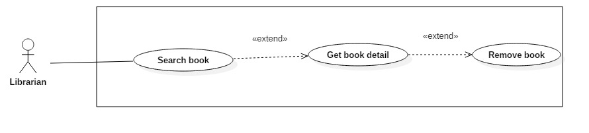

Figure 19: <Librarian> Remove Book

|  |  |  |  |
| --- | --- | --- | --- |
| **USE CASE – JWL13** | | | |
| **Use Case No.** | JWL12 | **Use Case Version** | 1.1 |
| **Use Case Name** | Remove Book | | |
| **Author** | Dang Nhat Thien | | |
| **Date** | March 15, 2017 | **Priority** | Normal |
| **Actor:**   * Librarian   **Summary:**   * This use case allows Librarian to remove books when all copies of books are unusable or the Library does not provide books anymore.   **Goal:**   * Librarian remove book and all of copies. The books and copies are not available in the library system. Borrowers can’t search and borrow.   **Triggers:**   * Librarian send Remove Book command.   **Preconditions:**   * Actor logged in system with role Librarian. * Librarian find out the Book want to remove via <Librarian> Search Book * The book must be available in the library system.   **Post Conditions:**   * **Success:** System show message: “Removed successfully!” * **Fail:** N/A   **Main Success Scenario:**   |  |  |  | | --- | --- | --- | | Step | Actor Action | System Response | | 1  2 | Librarian send “Remove” Book  Command on a specific book.  Librarian send “Yes” command.  [Alternative 1] | System displays confirmation message: “Are you sure to remove this book?”.  System removes the book and show message: “Removed successfully!”  [Exception 1] |   **Alternative Scenario:**   |  |  |  | | --- | --- | --- | | No | Cause | System Response | | 1 | Librarian send “Cancel” command. | System return to main view. |   **Exceptions:**   |  |  |  | | --- | --- | --- | | No | Cause | System Response | | 1 | The book is being borrowed. | System displays error message: “Book is being borrowed. Can’t be removed!” |   **Relationships:** Librarian must find out a book via<Librarian> Search Book to remove.  **Business Rules:**   * Book have copy is borrowing can’t be removed. * If book has been borrowed, change status to “false”. | | | |

###### <Librarian> Add Borrower

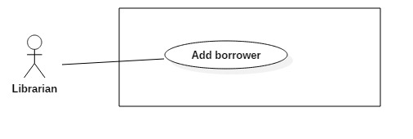

Figure 20: <Librarian> Add Borrower

|  |  |  |  |
| --- | --- | --- | --- |
| **USE CASE – JWL14** | | | |
| **Use Case No.** | JWL13 | **Use Case Version** | 1.0 |
| **Use Case Name** | Add Borrower | | |
| **Author** | Dang Nhat Thien | | |
| **Date** | February 13, 2017 | **Priority** | Normal |
| **Actor:**   * Librarian   **Summary:**   * This use case allows Librarian to create an account for Borrower when someone ask to subscribe the library.   **Goal:**   * New account for borrower is created with status: “Activate”.   **Triggers:**   * Librarian sends Create Borrower command.   **Preconditions:**   * Actor logged in system with role Librarian.   **Post Conditions:**   * **Success:** Show success message: “New account [userId] has been added!”. * **Fail:** N/A   **Main Success Scenario:**   |  |  |  | | --- | --- | --- | | Step | Actor Action | System Response | | 1 | Librarian sends Create Borrower  command. | System lists out the information of the new account:   * “User Image”: system image, only JPG, PNG, JPEG format are accepted. Maximum file size is 3 MB, required. * “User ID”: free text input, length 6-15 * “Full Name”: free text input, length 1-100 * “Password”: free text input that hides the input text, length 6-50 * “Confirm Password”: free text input that hides the input text, length 6-50 * “Email”: free text input * “Address”: free text input, length 1-250 * “Date of Birth”: view that allows Librarian to pick day – month - year * “Phone number”: free text input, length 8-12 * “Place of Work”: free text input: length 6-50 | | 2 | Librarian input the information. | System validate the corresponding field whenever text changed.  [Exception 1, 2, 3, 4, 5, 6, 7, 8, 9, 10, 11] | | 3 | Librarian sends “Save” command. | System validates the input then create a new borrower.  System displays a successful message: “New Borrower: [User Id] is added.”  [Exception 1, 2, 3, 4, 5, 6, 7, 8, 9, 10, 11] |   **Alternative Scenario:** N/A  **Exceptions:**   |  |  |  | | --- | --- | --- | | No | Cause | System Response | | 1 | Librarian pick up wrong format file. | System display error message: “Image extension are JPG, JPEG, PNG only and maximum size 3MB” | | 2 | Librarian does not pick up an image. | System display error message: “Please choose a picture for Borrower.” | | 3 | Librarian inputs User Id field with wrong format. | System displays error message: “User Id length is 6-15 characters.” | | 4 | Librarian inputs Full Name field with wrong format. | System displays error message: “Full name length is 1-100 characters.” | | 5 | Librarian inputs Password field with wrong format. | System displays error message: “Password length is 6-50 characters.” | | 6 | Librarian inputs Confirm Password field which does not match the Password. | System displays error message: “Confirm Password must match Password.” | | 7 | Librarian inputs Email field with wrong format. | System displays error message: “Wrong Email format. Please input something like abc@somemail.com” | | 8 | Librarian inputs Address field with wrong format. | System displays error message: “Address length is 1-125 characters.” | | 9 | Librarian don’t pick up a Date of Birth. | System displays error message: “Have to pick up a Date of Birth for borrower.” | | 10 | Librarian inputs Phone Number field with wrong format. | System displays error message: “Phone Number should be all numbers at 8-12 length.” | | 11 | Librarian inputs Place of Work field with wrong format. | System displays error message: “Place of Work length is 6-50 characters.” |   **Relationships:** Librarian create success a borrower account, so borrower can login to the system with borrower role.  **Business Rules:**   * Password must be encrypted before saving to the system. * Email format: abc@somemail.com | | | |

###### <Librarian> Search Borrower

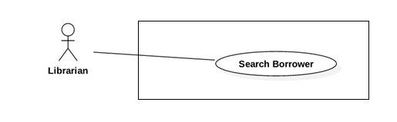

Figure 21: <Librarian> Search Borrower

|  |  |  |  |
| --- | --- | --- | --- |
| **USE CASE – JWL15** | | | |
| **Use Case No.** | JWL14 | **Use Case Version** | 1.0 |
| **Use Case Name** | Search Borrower | | |
| **Author** | Dang Nhat Thien | | |
| **Date** | February 13, 2017 | **Priority** | Normal |
| **Actor:**   * Librarian   **Summary:**   * This use case allows Librarian to search for a borrower when a borrower ask to update their information/ borrowing list.   **Goal:**   * Librarian can get a list borrower that match input username or full name.   **Triggers:**   * Librarian send Search Borrower command.   **Preconditions:**   * Actor logged in system with role Librarian.   **Post Conditions:**   * **Success:** List of matching borrowers based on search term is showed. * **Fail:** N/A   **Main Success Scenario:**   |  |  |  | | --- | --- | --- | | Step | Actor Action | System Response | | 1  2 | Librarian inputs wanted username or  full name.  Librarian send Search command. | System loads the result. Information for each Borrower:   * UserId * Full name * Email * Is in Library * Is activate * View detail command   [Alternative 1] |   **Alternative Scenario:**   |  |  |  | | --- | --- | --- | | Step | Cause | System Response | | 1 | There is no borrower that matches the search term. | System shows message: “No borrower found.” |   **Exceptions:** N/A  **Relationships:** Search book successfully, so librarian can Update borrower.  **Business Rules:** N/A | | | |

###### <Librarian> Get Borrower Detail

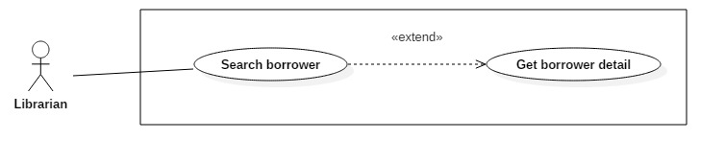

Figure 22: <Librarian> Get borrower detail.

|  |  |  |  |
| --- | --- | --- | --- |
| **USE CASE – JWL16** | | | |
| **Use Case No.** | JWL15 | **Use Case Version** | 1.0 |
| **Use Case Name** | Get Borrower Detail | | |
| **Author** | Dang Nhat Thien | | |
| **Date** | March 16, 2017 | **Priority** | Low |
| **Actor:**   * Librarian   **Summary:**   * This use case allows Librarian to view borrower’s detail. So Librarian can Update borrower’s profile.   **Goal:**   * Full information of borrower is displayed.   **Triggers:**   * Librarian sends View Profile Detail command.   **Preconditions:**   * Actor logged in system with role Librarian. * Librarian find out the Borrower want to view detail via <Librarian> Search Borrower   **Post Conditions:**   * **Success:** System show all information of a specific Borrower. * **Fail:** N/A.   **Main Success Scenario:**   |  |  |  | | --- | --- | --- | | Step | Actor Action | System Response | | 1 | Librarian sends View Borrower Detail. | System lists out the information of the account:   * User Id * Full name * Date of birth * Email * Address * Phone number * Place of work * Status |   **Alternative Scenario:** N/A  **Exception:** N/A  **Relationships:** Librarian must find out the Borrower want to view detail via <Librarian> Search Borrower  **Business Rules:** N/A | | | |

###### <Librarian> Update Borrower

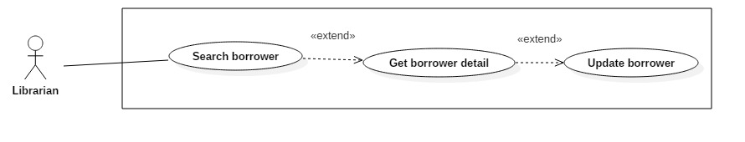

Figure 23: <Librarian> Update Borrower

|  |  |  |  |
| --- | --- | --- | --- |
| **USE CASE – JWL17** | | | |
| **Use Case No.** | JWL15 | **Use Case Version** | 1.1 |
| **Use Case Name** | Update Borrower Information | | |
| **Author** | Dang Nhat Thien | | |
| **Date** | March 16, 2017 | **Priority** | Low |
| **Actor:**   * Librarian   **Summary:**   * This use case allows Librarian to update borrower’s information when borrower ask.   **Goal:**   * Borrower’s information is changed.   **Triggers:**   * Librarian sends Update command.   **Preconditions:**   * Actor logged in system with role Librarian. * Librarian find out the Borrower want to update via <Librarian> Search Borrower   **Post Conditions:**   * **Success:** A message is displayed: “Update successfully!”. * **Fail:** N/A.   **Main Success Scenario:**   |  |  |  | | --- | --- | --- | | Step | Actor Action | System Response | | 1 | Librarian sends Update Account command on a specific account. | System lists out the information of the new account:   * “User Image”: system image, only JPG, PNG, JPEG format are accepted. Maximum file size is 3 MB, required. * “User ID”: free text input, length 6-15 * “Full Name”: free text input, length 1-100 * “Password”: free text input that hides the input text, length 6-50 * “Confirm Password”: free text input that hides the input text, length 6-50 * “Email”: free text input * “Address”: free text input, length 1-250 * “Date of Birth”: view that allows Librarian to pick day – month - year * “Phone number”: free text input, length 8-12   “Place of Work”: free text input: length 6-50 | | 2 | Librarian updates information. | System validate the corresponding field whenever text changed.  [Exception 1, 2, 3, 4, 5, 6, 7, 8, 9, 10, 11] | | 3 | Librarian sends Submit command. | System validates the input then update borrower.  System displays a successful message: “Update successfully!”  [Exception 1, 2, 3, 4, 5, 6, 7, 8, 9, 10, 11] |   **Alternative Scenario:** N/A  **Exception:**   |  |  |  | | --- | --- | --- | | No | Cause | System Response | | 1 | Librarian pick up wrong format file. | System display error message: “Image extension are JPG, JPEG, PNG only and maximum size 3MB” | | 2 | Librarian does not pick up an image. | System display error message: “Please choose a picture for Borrower.” | | 3 | Librarian inputs User Id field with wrong format. | System displays error message: “User Id length is 6-15 characters.” | | 4 | Librarian inputs Full Name field with wrong format. | System displays error message: “Full name length is 1-100 characters.” | | 5 | Librarian inputs Password field with wrong format. | System displays error message: “Password length is 6-50 characters.” | | 6 | Librarian inputs Confirm Password field which does not match the Password. | System displays error message: “Confirm Password must match Password.” | | 7 | Librarian inputs Email field with wrong format. | System displays error message: “Wrong Email format. Please input something like abc@somemail.com” | | 8 | Librarian inputs Address field with wrong format. | System displays error message: “Address length is 1-125 characters.” | | 9 | Librarian don’t pick up a Date of Birth. | System displays error message: “Have to pick up a Date of Birth for borrower.” | | 10 | Librarian inputs Phone Number field with wrong format. | System displays error message: “Phone Number should be all numbers at 8-12 length.” | | 11 | Librarian inputs Place of Work field with wrong format. | System displays error message: “Place of Work length is 6-50 characters.” |   **Relationships:** Librarian must find out the Borrower want to update via <Librarian> Search Borrower  **Business Rules:**   * Password must be encrypted before saving to the system. * Email format: something like abc@somemail.com. | | | |

#### Mobile Application

##### Borrower

###### <Borrower> Overview Use Case

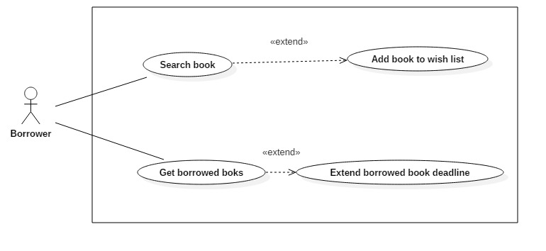

Figure 24: <Borrower> Overview Use Case

###### <Borrower> Search Book

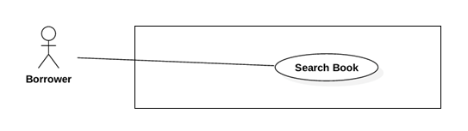

Figure 25: <Borrower> Search Book

|  |  |  |  |
| --- | --- | --- | --- |
| **USE CASE – JWL17** | | | |
| **Use Case No.** | JWL17 | **Use Case Version** | 1.1 |
| **Use Case Name** | Search Book | | |
| **Author** | Dang Nhat Thien | | |
| **Date** | March 16, 2017 | **Priority** | Normal |
| **Actor:**   * Borrower   **Summary:**   * This use case allows Borrowers to search book. So that borrowers can view status of book, add book to wish list.   **Goal:**   * A list books that match input book’s name, book’s author or book’s category is displayed.   **Triggers:** Borrower send Search Command.  **Preconditions:**   * Actor logged in system with role Borrower.   **Post Conditions:**   * **Success:** List of matching books based on search term is showed. * **Fail:** A Dialog will be showed and display message: “Search fail. Please check your internet connection”.   **Main Success Scenario:**   |  |  |  | | --- | --- | --- | | Step | Actor Action | System Response | | 1 | Borrower inputs wanted book’s name, book’s author or book’s category.  Then send Search Command | System loads the result. Information for each account:   * Book Title * Publisher * Description * Publish year * Number of pages * Number of copies * Book type * Position * ISBN * “Get book detail” command   [Alternative 1]: There is no book that matches the search term.  [Exception 1]: Internet connection is lost. |   **Alternative Scenario:**   |  |  |  | | --- | --- | --- | | Step | Cause | System Response | | 1 | There is no book that matches the search term. | System shows message: “No book found.” |   **Exceptions:**   |  |  |  | | --- | --- | --- | | No | Cause | System Response | | 1 | Internet connection is lost. | System show error message via Dialog. |   **Relationships:** Search successfully so Borrower can add book to wish list if Book is not available at that time.  **Business Rules:**   * Search return the most matched book with the search term. | | | |

###### <Borrower> Add Book To Wish List

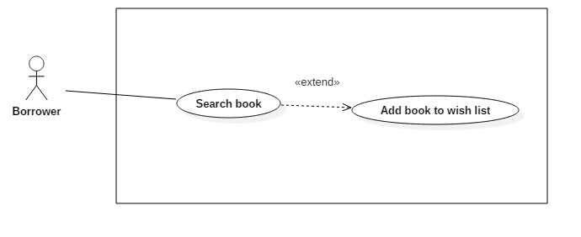

Figure 26: <Borrower> Add book to wish list

|  |  |  |  |
| --- | --- | --- | --- |
| **USE CASE – JWL18** | | | |
| **Use Case No.** | JWL18 | **Use Case Version** | 1.1 |
| **Use Case Name** | Add Book To Wish List | | |
| **Author** | Dang Nhat Thien | | |
| **Date** | March 16, 2017 | **Priority** | Normal |
| **Actor:**   * Borrower   **Summary:**   * Borrower Add Book To Wish List if a book is not available, when book copies is returned, Borrower will receive notification.   **Goal:**   * The book is saved as wish book of specific Borrower.   **Triggers:** Borrower send “Add Book To Wish List” command.  **Preconditions:**   * Actor logged in system with role Borrower. * Borrower find out the book. * Book is not available.   **Post Conditions:**   * **Success:** A dialog will be showed and display message: “Add successfully”. * **Fail:** A dialog will be showed and display message: “Add fail. Please check your internet connection”.   **Main Success Scenario:**   |  |  |  | | --- | --- | --- | | Step | Actor Action | System Response | | 1 | Borrower send “Add To Wish List” command | * System save to database and display success message.   [Exception 1] Lost Internet Connection |   **Alternative Scenario:** N/A  **Exceptions:**   |  |  |  | | --- | --- | --- | | No | Cause | System Response | | 1 | Lost Internet Connection | System show error message via Dialog. |   **Relationships:** Borrower must search book via Search book before.  **Business Rules:**   * Borrower can only add books are not available to wish list. | | | |

###### <Borrower> Get Borrowed Books

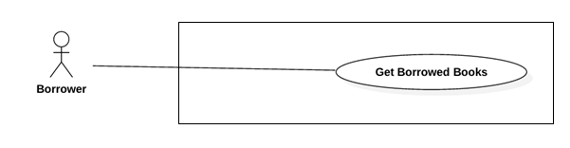

Figure 27: <Borrower> Get Borrowed Books

|  |  |  |  |
| --- | --- | --- | --- |
| **USE CASE – JWL19** | | | |
| **Use Case No.** | JWL19 | **Use Case Version** | 1.1 |
| **Use Case Name** | Get Borrowed Books | | |
| **Author** | Dang Nhat Thien | | |
| **Date** | March 16, 2017 | **Priority** | Normal |
| **Actor:**   * Borrower.   **Summary:**   * Borrower get list borrowed books so can check deadline.   **Goal:**   * List borrowed books is displayed.   **Triggers:** Borrower send “Get borrowed books” command.  **Preconditions:**   * Actor logged in system with role Borrower.   **Post Conditions:**   * **Success:** List borrowed books is displayed. * **Fail:** A dialog will be showed and display message: “Loading fail. Please check your internet connection”.   **Main Success Scenario:**   |  |  |  | | --- | --- | --- | | Step | Actor Action | System Response | | 1 | Borrower send “Get borrowed books” command. | System show list borrowed books.  [Exception 1] Lost Internet Connection. |   **Alternative Scenario:** N/A  **Exceptions:**   |  |  |  | | --- | --- | --- | | No | Cause | System Response | | 1 | Lost Internet Connection | System show error message via Dialog. |   **Relationships:** After Get Borrowed Books, Borrower can Extend Borrower Book Deadline.  **Business Rules:** N/A | | | |

###### <Borrower> Extend Borrowed Book Deadline

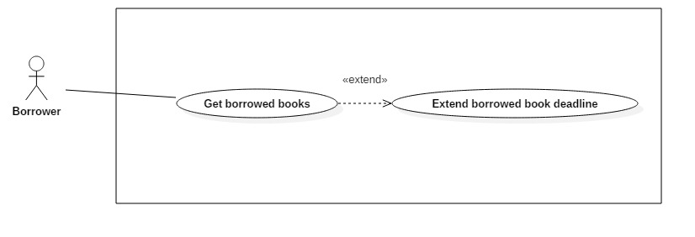

Figure 28: <Borrower> Extend Borrowed Book Deadline

|  |  |  |  |
| --- | --- | --- | --- |
| **USE CASE – JWL20** | | | |
| **Use Case No.** | JWL20 | **Use Case Version** | 1.1 |
| **Use Case Name** | Extend Borrowed Book Deadline | | |
| **Author** | Dang Nhat Thien | | |
| **Date** | March 16, 2017 | **Priority** | Normal |
| **Actor:**   * Borrower   **Summary:**   * The deadline is coming however borrower don’t want to return that time, he can extend book, deadline will be changed.   **Goal:**   * Book Deadline will be added by Extend day of specific book.   **Triggers:** N/A  **Preconditions:**   * Actor logged in system with role Borrower. * Book is not overdue the deadline. * Extend number must be bigger than 0.   **Post Conditions:**   * **Success:** A dialog will be showed and display message: “Book [title] has been extends to [deadline]!” * **Fail:** A dialog will be showed and display message: “Loading fail. Please check your internet connection!”.   **Main Success Scenario:**   |  |  |  | | --- | --- | --- | | Step | Actor Action | System Response | | 1 | After get list borrowed books, Borrower click on “Extends” button in Book detail. | System return new deadline and show success message.  [Exception 1] Lost Internet Connection. |   **Alternative Scenario:** N/A  **Exceptions:**   |  |  |  | | --- | --- | --- | | No | Cause | System Response | | 1 | Lost Internet Connection | System display error message. |   **Relationships:** Borrower can Extend Borrower Book Deadline after get Borrowed Booksvia <Borrower> Get Borrowed Books  **Business Rules:** Book only can be extended when:   * Book is not overdue the deadline. * Extend number must be bigger than 0. | | | |

##### Automatic Handler

###### <Automatic Handler> Overview Use Case

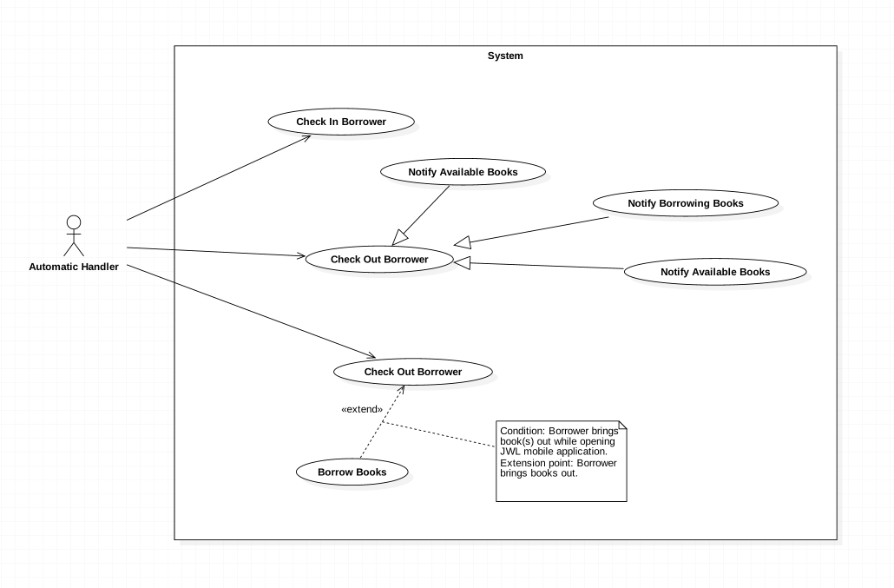

Figure 29: <Automatic Handler> Overview Use Case

###### <Automatic Handler> Check in Borrower

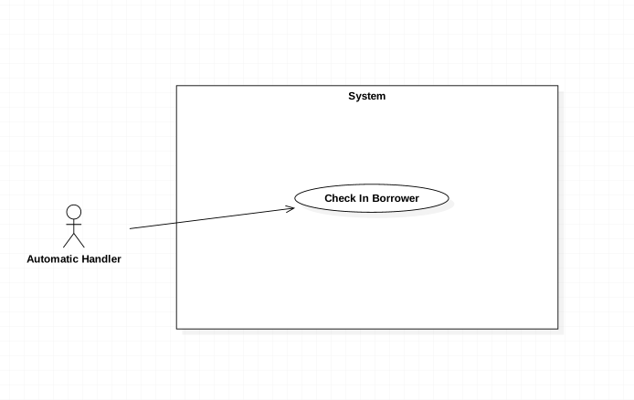

Figure 30: <Automatic Handler> Check in Borrower

|  |  |  |  |
| --- | --- | --- | --- |
| **USE CASE – JWL21** | | | |
| **Use Case No.** | JWL21 | **Use Case Version** | 2.0 |
| **Use Case Name** | Check in Borrower | | |
| **Author** | Vo Hong Ha | | |
| **Date** | February 13, 2017 | **Priority** | High |
| **Actor:**   * Automatic Handler   **Summary:**   * This use case allows Automatic Handler to check the attendance of those want to enter the library.   **Goal:**   * Authenticate the borrowers’ information.   **Triggers:**   * Automatic Handler checks the information of borrowers when they scan smartphone at the entrance.   **Preconditions:**   * Borrower scans NFC/QR code through the emulator.   **Post Conditions:**   * **Success:** The message will show on the application. * **Fail:** N/A   **Main Success Scenario:**   |  |  |  | | --- | --- | --- | | Step | Actor Action | System Response | | 1 | Automatic Handler check the information.  [Alternative 1] | System response the message of result “You are at the library” |   **Alternative Scenario:**  Alternative 1:   |  |  |  | | --- | --- | --- | | Step | Actor Action | System Response | | 1 | The information of borrowers is wrong. | System response the message of result “Please check your NFC/ QR Core again” |   **Exceptions:** N/A  **Relationships:** N/A  **Business Rules:**   * Automatic Handler gets the information of NFC/QR code from the emulator then sends to the system. * Automatic Handler receives the response of the system and rings the bell or display notification in comparable with that response. | | | |

###### <Automatic Handler> Notify return date

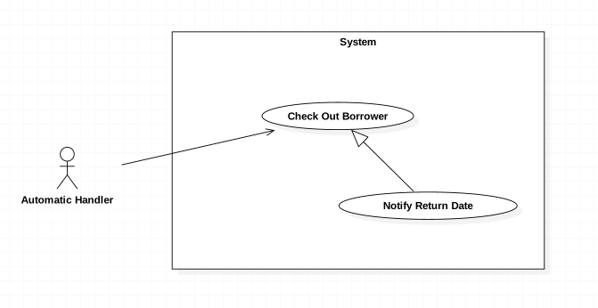

Figure 31: <Automatic Handler> Notify return date

|  |  |  |  |
| --- | --- | --- | --- |
| **USE CASE – JWL22** | | | |
| **Use Case No.** | JWL22 | **Use Case Version** | 1.0 |
| **Use Case Name** | Notify return date | | |
| **Author** | Vo Hong Ha | | |
| **Date** | February 13, 2017 | **Priority** | Normal |
| **Actor:**   * Automatic Handler   **Summary:**   * This use case allows Automatic Handler to send a notification to borrower about the return date of books   **Goal:**   * Borrowers are noticed 3 days prior to the return date.   **Triggers:**   * Automatic Handler send a notification to the borrower.   **Preconditions:**   * Borrower has borrowed books that have 3 days remaining.   **Post Conditions:**   * **Success:** Notification will be sent to the borrowers on the mobile application. * **Fail:** N/A   **Main Success Scenario:**   |  |  |  | | --- | --- | --- | | Step | Actor Action | System Response | | 1 | Automatic Handler send notification on noticed day. | System push a notification on the application of mobile phone:  “3 days remaining for [bookTitle]” |   **Alternative Scenario:** N/A  **Exceptions:** N/A  **Relationships:** N/A  **Business Rules:**   * The second notification will be sent on the return date in the case that the book was not returned until that date. | | | |

###### <Automatic Handler> Notify Borrowing Books

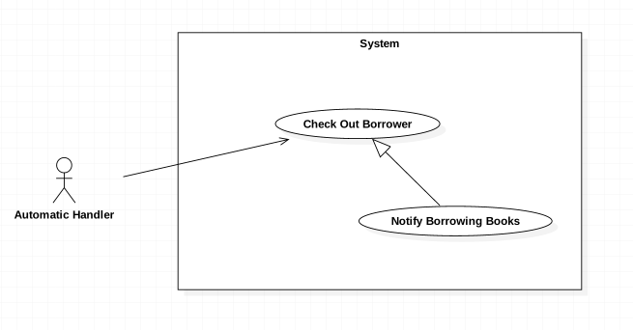

Figure 32: <Automatic Handler> Notify Borrowing Books

|  |  |  |  |
| --- | --- | --- | --- |
| **USE CASE – JWL23** | | | |
| **Use Case No.** | JWL23 | **Use Case Version** | 1.0 |
| **Use Case Name** | Notify Borrowing Books | | |
| **Author** | Vo Hong Ha | | |
| **Date** | February 13, 2017 | **Priority** | Normal |
| **Actor:**   * Automatic Handler   **Summary:**   * This use case allows Automatic Handler to send a notification to borrowers about the borrowed book after they borrow   **Goal:**   * Borrowers are noticed those books which they have borrowed   **Triggers:**   * Automatic Handler notices the list of borrowed book   **Preconditions:**   * Borrower borrow books and check out successfully.   **Post Conditions:**   * **Success:** Notification will be sent with a list of borrowed book * **Fail:** N/A   **Main Success Scenario:**   |  |  |  | | --- | --- | --- | | Step | Actor Action | System Response | | 1 | Automatic Handler send notification right after Borrower check out. | System push a notification on the application of mobile phone:  “You have check out successfully. The list of book is as follow.” |   **Alternative Scenario:** In the case the borrowers don’t check out with books, the notification will not be sent.  **Exceptions:** N/A  **Relationships:** N/A  **Business Rules:** N/A | | | |

###### <Automatic Handler> Notify Available Books

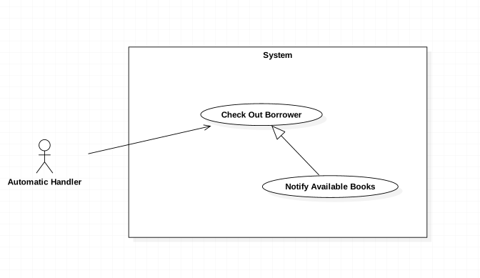

Figure 33: <Automatic Handler> Notify Available Books

|  |  |  |  |
| --- | --- | --- | --- |
| **USE CASE – JWL24** | | | |
| **Use Case No.** | JWL24 | **Use Case Version** | 1.0 |
| **Use Case Name** | Notify Available Books | | |
| **Author** | Vo Hong Ha | | |
| **Date** | February 13, 2017 | **Priority** | Normal |
| **Actor:**   * Automatic Handler   **Summary:**   * This use case allows Automatic Handler to send a notification to borrowers about the available book according to borrower’s wish list.   **Goal:**   * Borrowers are noticed those books which are available in the library.   **Triggers:**   * Automatic Handler notices the available books.   **Preconditions:**   * Borrowers have add that books to their wish list and those books are available on the library.   **Post Conditions:**   * **Success:** Notification about the available books will be sent. * **Fail:** N/A   **Main Success Scenario:**   |  |  |  | | --- | --- | --- | | Step | Actor Action | System Response | | 1 | Automatic Handler send notification about available books. | System push a notification on the application of mobile phone:  “Some books of your wish list have available” |   **Alternative Scenario:** N/A  **Exceptions:** N/A  **Relationships:** N/A  **Business Rules:** N/A | | | |

###### <Automatic Handler> Check out Borrower

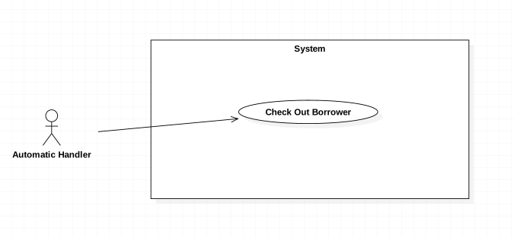

Figure 34: <Automatic Handler> Check out Borrower

|  |  |  |  |
| --- | --- | --- | --- |
| **USE CASE – JWL25** | | | |
| **Use Case No.** | JWL25 | **Use Case Version** | 1.0 |
| **Use Case Name** | Check out Borrower | | |
| **Author** | Vo Hong Ha | | |
| **Date** | February 13, 2017 | **Priority** | High |
| **Actor:**   * Automatic Handler   **Summary:**   * This use case allows Automatic Handler to check out the borrower.   **Goal:**   * Check the borrowers who get out of the library.   **Triggers:**   * N/A.   **Preconditions:**   * N/A.   **Post Conditions:**   * **Success:** N/A. * **Fail:** N/A   **Main Success Scenario:**   |  |  |  | | --- | --- | --- | | Step | Actor Action | System Response | | 1 | Automatic Handler check the borrower with RFID reader. | N/A |   **Alternative Scenario:** N/A  **Exceptions:** N/A  **Relationships:** N/A  **Business Rules:** N/A | | | |

###### <Automatic Handler> Check out Borrow Books

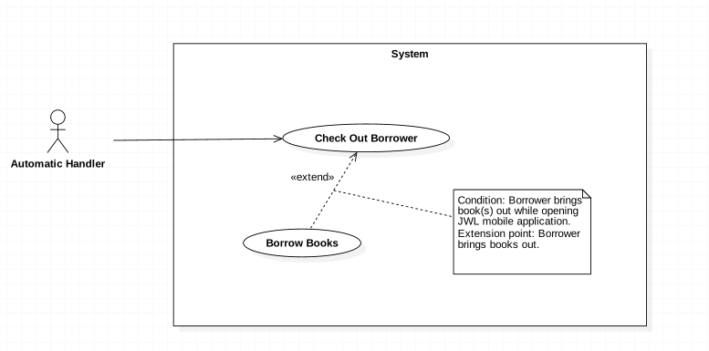

Figure 35: <Automatic Handler> Check out Borrow Books

|  |  |  |  |
| --- | --- | --- | --- |
| **USE CASE – JWL26** | | | |
| **Use Case No.** | JWL26 | **Use Case Version** | 1.0 |
| **Use Case Name** | Check out Borrow Books | | |
| **Author** | Vo Hong Ha | | |
| **Date** | February 13, 2017 | **Priority** | High |
| **Actor:**   * Automatic Handler   **Summary:**   * This use case allows Automatic Handler to check out the borrower’s books.   **Goal:**   * Check out the borrower whether they get out with books.   **Triggers:**   * RFID Reader scan the books of the Borrower.   **Preconditions:**   * The books have RFID tag.   **Post Conditions:**   * **Success:** N/A. * **Fail:** N/A   **Main Success Scenario:**   |  |  |  | | --- | --- | --- | | Step | Actor Action | System Response | | 1 | Automatic Handler scan the books with RFID reader. | Add the books to the borrowed list. |   **Alternative Scenario:** N/A  **Exceptions:** N/A  **Relationships:** N/A  **Business Rules:** N/A | | | |

## Software System Attribute



### Usability

* The Android application for emulator requires 10 minutes training for staff.
* The Android application for passenger will take 10-30 minutes to get used to the mobile system completely

### Reliability

* The number of sending notification failure is 1 time per 1000 notifications.
* Timer tasks run at configured time with 100% execution rate.

### Availability

* System is available 24 hours per day and 7 days per week.
* System should take at most 5 hours per month for backup or repairing.

### Security

* Privacy: Each role of user has a specific permission to interact with system.
* System requires SMS verification for all users.
* System always checks authorization and authenticated before doing anything.
* Only admin can grant permission to other roles.

### Maintenanability

* The system is divided into separated modules.
* The code is easy to maintain and upgrade.

### Portability

* The web application is running on Windows Server 2008 or above.
* Mobile application for passenger and emulator runs on Android API greater than 4.1.
* Providing easy installation.

### Performance

* Web appication handles the task within 10 seconds.
* System response time of SMS message depend on telecomunications infrastructurs and server.
* Emulator reads data from NFC card in less than 5 second within the distance between 0 centimeter and 1 centimeter in the condition with no obstacle.

## Conceptual Diagram



Figure 45: Conceptual Diagram

**Data Dictionary:**

|  |  |
| --- | --- |
| Entity Name | Description |

Table 35: Conceptual Diagram Data Dictionary